**TML Leadership Academy**

**Course Two: Ethical and Influential Leadership**

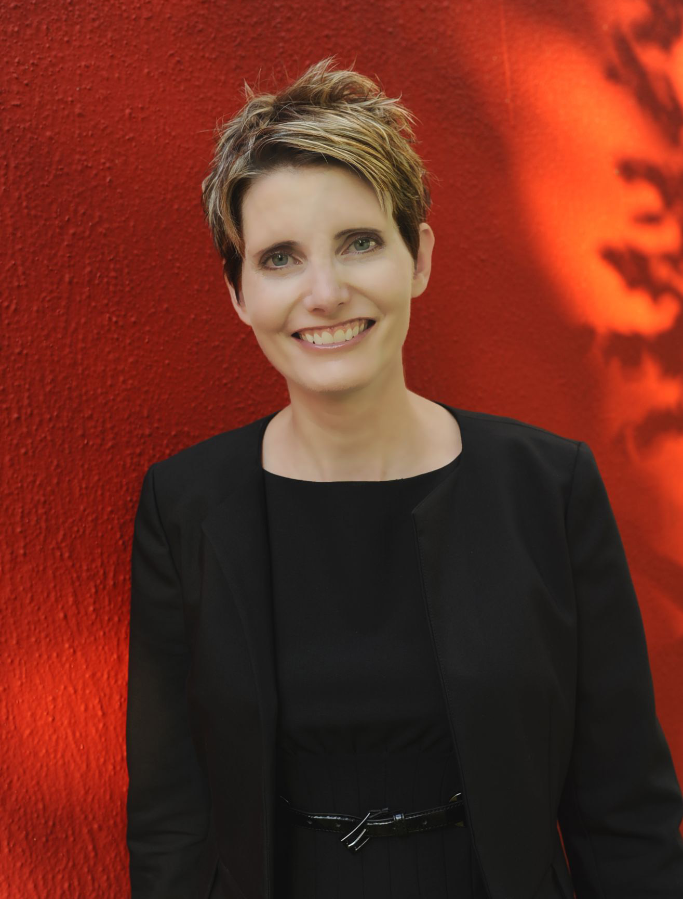

**Ethical Leadership: Helping Good People Do Good Things  
Cindi Baldi**, PhD, Founder and CEO, Culsure

Ethical leaders bring out the best in others, especially under conditions of uncertainty and change. The leaders we admire—throughout history and from our own lives—have a remarkable ability to inspire when the situation seems dire. Although ethical decision making isn’t easy, there are straightforward leadership strategies to bring out the best in others. Most people desperately want to do the right thing and to live the kind of life that enables them to sleep well at night. A few enduring ethical strategies can help everyone around you do good, better.

***Dr. Cindi Baldi*** *is the founder and CEO of Culsure, a management science firm, and the senior organizational consultant at On-Demand Leadership. Cindi holds a PhD, an MBA, and an MS in Management from the McCombs School of Business at the University of Texas at Austin, and a BS in Management from the University of North Carolina at Wilmington. She is an expert on organizational behavior and effectiveness and has presented her research worldwide at institutions like the Stanford Business School, the INSEAD School of Business in France, and Ben-Gurion University in Israel. Cindi is a serial entrepreneur who has created profitable companies throughout the United States. Growing up, her family owned—and Cindi worked in—a haunted house, a video arcade, a drive-in movie theater, and a zoo. As a result, she knows a ton about animals and horror movies. She can also beat you at Galaga.*